Easy Read – Zero Tolerance
Violence, Abuse, Neglect and Exploitation
 | This document shows how Able Disability Services prevents or manages violence, abuse, neglect and exploitation.
 | You have the right to enjoy a life free from violence, abuse, neglect and exploitation.
 | You should always feel safe when receiving supports from us.  If you feel unsafe, tell Able Disability Managing Director immediately.
 | Violence is when someone hurts you physically (like hitting, punching or slapping you).
 | Abuse is when someone mistreats you and hurts your body or your feelings.
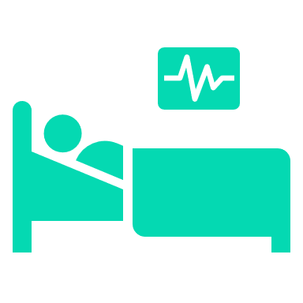 | Neglect is when someone is not caring for you or helping you how they are supposed to.
 | Exploitation is when someone is taking advantage of you.
 | Able Disability Services does not allow any acts of violence, abuse, exploitation or neglect towards you.
 | It is our responsibility to protect you and keep you safe.
 | We want you to tell us if someone hurts you or does not feel safe with someone.
 | If you do not feel comfortable telling us, you should tell someone you trust, like your:  - mum or dad  - brother or sister  - support worker.
 | Or you can get help from a professional, independent advocate.
 | We can help you find an advocate if you want.  Ask our Able Disability Managing Director for help. Call 0418 148 531
 | You can also get help by calling the  National Disability Abuse Hotline on 1800 880 052.
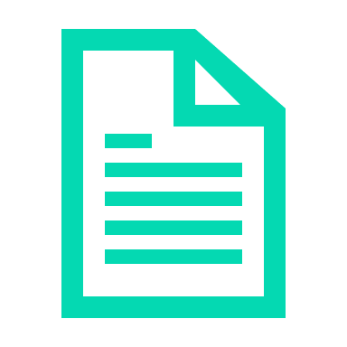 | To keep you safe, we will:  - make sure our staff follow the rules  - train staff on how to help you  - keep your information private.
 | Able Disability Services will always:  - support you if something terrible happens  - call the police if we need to.
We will always:
- listen to you or your advocate
- provide you with the support you need
- keep you updated on what is going on.
If you are not happy with how we are helping you tell the NDIS Commission: Call 1800 03 55 44
Go online www.ndiscommission.gov.au

