Easy Read – Money & Property
How will we look after your money & property?
 | This document tells you how we will look after your money and property.
 | You are the owner of your money and property.  If you say that it is okay, we can help you to buy things with your money and we will use your property to deliver your services.
 | We can only use your money or property if you have agreed and it is written in your Service Agreement.
 | You agree to our staff helping you use by completing the Participant Money and Property Consent Form.
 | Property:  - Our staff will only use your property if it is needed to help deliver your services.  - You must tell us it is okay to use your property.  - We will add a list of property that can be used into your Support Plan.
 | Money:  - You tell us how you want to spend your money.  - Our staff cannot touch your money without permission.
 | If you ask a support worker to help you spend your money, they must check they can with the Able Disability Managing Director.
 | Our staff cannot use your PIN number or get money from an ATM because this is your VERY private information.
 | If a support worker helps you with your money, they must follow our rules to keep you and your money safe.
 | Our staff will keep all of the receipts for things they have used your money to buy.  They will keep a record of all of your money that has been spent.
 | Staff will count out your money with you before buying something.  They will count out your change after buying something.  You will both sign a record agreeing your money was correctly spent.
 | Able Disability will tell you how and when your money was spent.
 | Our staff cannot give you any advice or information about money matters.
 | If we think someone is misusing your money or property, Able Disability will tell you.
 | If you think someone is misusing your money or property, tell the Able Disability Managing Director immediately.
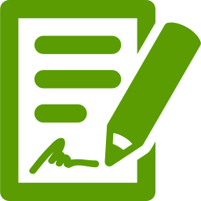 | The Able Disability Managing Director will:  - Investigate, record evidence and write a report  - tell the police or other authorities, if needed  - provide additional support to you (if needed).
 | If you want help after the Service Agreement is written, we will:  - talk with you about the help you need  - write everything in your notes

