Easy Read – Conflict of Interest
 | This document explains what a conflict of interest is and what Able Disability Services does to manage them.
 | A conflict of interest occurs when a staff member's interests differ from Able Disability Services' or your best interests.
 | Our staff should always do what is best for you and Able Disability Services.
 | Our staff's interests are called private interests.
 | A private interest can be:  ● direct – something owned by the person  ● indirect – something owned by a family member or a close friend.
 | A private interest can also be:  ● financial – getting money from it  ● non-financial – builds personal relationships in the community or with friends and family.
 | It is okay for staff to have a conflict of interest if they tell Able Disability Services.  We can then decide what to do about their conflict of interest to manage it.
 | A conflict of interest may be:  ● actual – it happened  ● potential – it could become a problem  ● perceived – it seems like a conflict but is okay as long as it is monitored.
 | A conflict of interest is wrong when a staff member uses it to get more than they should for themselves or their friends.
 | A conflict of interest can happen if a staff member's close friends or family become involved in work decisions.
 | A conflict of interest can happen if a staff member gets extra money by working for a different company while working at Able Disability Services.
 | A conflict of interest happens when our staff:  ● are involved with another organisation  ● encourage you to use the other Provider to receive supports.
  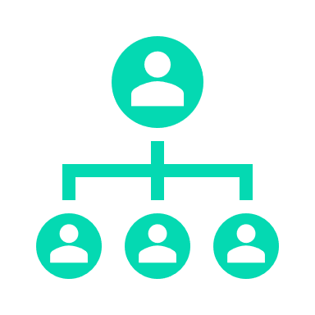 | How does Able Disability Services manage a staff conflict of interest?
 | We ask all of our staff to tell us (declare) their conflict of interest as soon as possible.
 | The Able Disability Services Director assesses all staff conflicts of interest to make sure they will not severely impact our organisation or you in any way.
 | The Able Disability Services Director will manage and monitor all declared conflicts to ensure they continue not to impact you or us.
 | We regularly check that conflicts of interest are not impacting Able Disability's:  ● support provision  ● quality of support  ● good decision-making.
 | How do we ensure no conflict of interest with a participant?
 | The Able Disability Services Director will discuss any identified conflicts of interest that could impact the support you receive.
 | The Able Disability Services Director will explain how we manage the conflict.
 | We want you to tell us if you are unhappy about managing the conflict of interest.
 | We will work with you to try and make changes to make you happy.
 | Any decisions you make about your providers or supports will not impact the current supports we provide you.
 | Using other providers will not impact the quality of supports you receive from Able Disability Services.
 | If we cannot fix the conflict of interest and are unhappy, we may refer you to another provider.
 | We will talk with you about this.  We will work out the best way for you to continue receiving the supports you need.
 | If you are referred to another provider, we will assist with your transition from our service.

